Worth 0% of your year mark.

**Greenwood College   
Year 12 Maths Methods 2020   
Investigation 1   
Take-Home Part**

**Take-home distribution date: Thursday 4 March 2020**

**In-class part completion date: Thursday 4 March 2018**

**Name: __________________**

The in-class part of this assessment will be done under test conditions without access to notes or this take-home part.

**Function Behaviour**

When recording your observations, the mathematical terms “curvature”, “dilation”, “factor”, “translation” and “reflection” should be mentioned when appropriate.

* (1)  Draw the following functions:
* 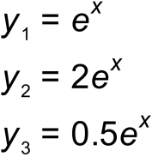
* (2)  Record what you have observed on the Casio Classpad screen.



(3)  Draw the following functions:

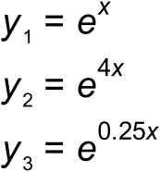

(4)  Record what you have observed.

(5)  Draw the following functions:

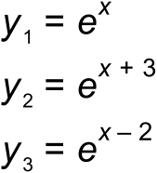

(6)  Record what you have observed.

(7)  Draw the following functions:

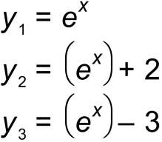

(8)  Record what you have observed.

(9) Using your previous observations, how does  compare with 

(10) Does  have a stationary point?

(11) Does  have sections which are concave upwards/concave

downwards?

(12)  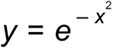 is found in the Normal probability distribution function.

Does have a stationary point?

(13) Does have sections which are concave upwards/concave downwards?

(14) Does 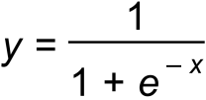 have a stationary point?

(15) Does  have sections which are concave upwards/concave downwards?

(16)  Use Wikipedia to learn about Catenary Curves in the real world.

(17)  The function of a “regular” Catenary Curve in Cartesian  co-ordinates has the form of 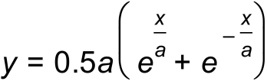.

Plot on the same graph, a “regular” Catenary Curve for the following values of “a”: 0.25; 0.5; 1; 2; 4; 8

(18) Find the first- and second- derivative functions of the “regular” Catenary function. Is there a pattern among the functions?

(19) Does the “regular” Catenary function have stationary points?

(20) For which values of x is the “regular” Catenary curve concave upwards/downwards?

Name: _________________________

**Greenwood College   
Year 12 Maths Methods 2020  
Investigation 1  
In-class Part**

Worth 10% of your year mark. No notes. Take home part must be submitted with In class part. Calculators allowed.   
52 marks total. 55 minutes of working time.

(1)  is the general form of an exponential function where “a”, “b”, “c” and “d” are constants.

(a)  Which constant/s control the translation of the general exponential function? (1 mark)

(b)  Which constant/s control the dilation of the general exponential function to the x-axis. (1 mark)

c)  Which constant/s control the dilation of the general exponential  function to the y axis. (1 mark)

(d)  In terms of constant/s, how is  translated along the x-axis only from (2 marks)

(e)  Find the first derivative of  (1 mark)

(f) Find the second derivative of  (1 mark)

(2) Given , show that  does not

have a stationary point. (1 mark)

(3)  Show (using calculus) that is concave upwards for   (2 marks)

(4)  What is the exponential function if  is reflected around the y-axis?   
(1 mark)

(5) What is the exponential function if is first reflected around the x-axis and then reflected around the y-axis? (2 marks)

(6)

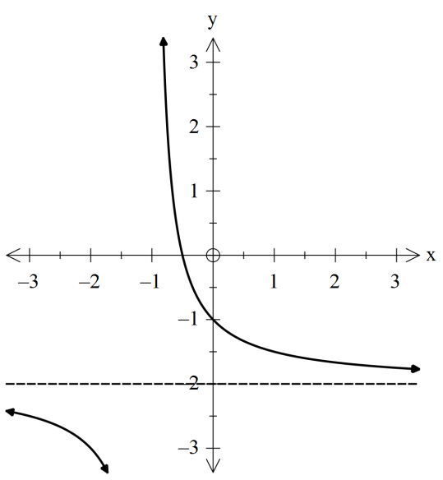

The function above has a vertical asymptote at x = -1 and a horizontal asymptote at y = -2.

Describe the asymptote/s for . (2 marks)

(7) 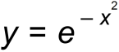is the function that is used to generate the Normal probability distribution function.

(a) Does it have a stationary point and, if so, where is it located?(2 marks)

(b)  For which values of x does  concave downwards? (3 marks)

(8)

(a) Sketch 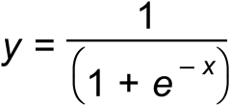 (2 marks)

(b)  Sketch for  (2 marks)

(c)  Where is the maximum value of ? (1 mark)

(d)  Describe how  changes from  . (2 marks)

(e) Assuming positive values for constant “A”. Investigate the effects of changing “A” in 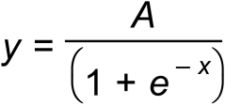. What did you observe when “A” increases? (2 marks)

(f) Assuming positive values for constant “B”. Investigate the effects of changing “B” in 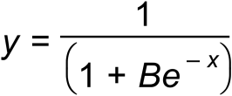. What did you observe when “B” increases? (2 marks)

(g) Assuming positive values for constant “C”. Investigate the effects of changing “C” in 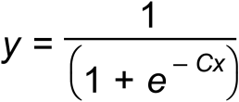. What did you observe when “C” increases? (2 marks)

(9) The function of a “regular” catenary in Cartesian co-ordinates has the form 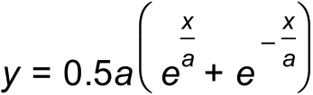 with the assumption .

(a) Starting with a value of , what happens to the shape and location of the “regular” catenary curve when the value of “a” increases? (2 marks)

(b) Show, with algebraic reasoning, that the “regular” catenary curve does not cross the x-axis. (3 marks)

(c) Does the “regular” catenary curve have a maximum point, minimum point or point of inflection? Show working. (3 marks)

(11) An engineer is modeling the central part of a suspension bridge (between the towers) using catenary equations. The length of the road between the towers is 100m.

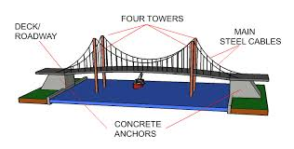

(a) if he modelled the central wire using a “regular” catenary equation with $a=19.5$, sketch a diagram showing the height of the towers above the road and the minimum height of the cable above the road (show working/diagram). (3 marks)

(12) The engineer then attempted to model the problem using a “modified” catenary equation $y=0.5a\left(e^{\frac{b\left(x+c\right)}{a}}+e^{\frac{-b\left(x+c\right)}{a}}\right)+d$.

(a) describe the transformations (using the words translation, dilation, to x axis, to y axis, horizontal, vertical) made with the modified catenary equation

$y=0.5a\left(e^{\frac{b\left(x+c\right)}{a}}+e^{\frac{-b\left(x+c\right)}{a}}\right)+d$ by varying a,b,c or d.

a:

b:

c:

d:

(4 marks)

(b) Given:

* the towers are 30m above the road,
* has a minimum span between the towers of 100m
* the wire has a clearance of 10m above the middle of the road
* the road itself is horizontal.

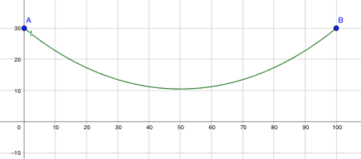

(a) Find values of a,b,c,d in the modified catenary equation

$y=0.5a\left(e^{\frac{b\left(x+c\right)}{a}}+e^{\frac{-b\left(x+c\right)}{a}}\right)+d$ to model the central wire suspended across the road (show working). (4 marks)